SET 8 – EMPLOYEE PERFORMANCE ANALYSIS
Ayesha Siddiqa S -04
192324305
Dataset: Employee Performance
Employee ID | Department | Years of Service | Performance Score
1 | Sales | 5 | 85
2 | HR | 3 | 92
3 | Marketing | 7 | 78

Question 1: Create a Line Chart to Visualize Performance Trend
Aim
To visualize employee performance scores with respect to years of service.
Algorithm
- Import the employee performance data.
- Drag Years of Service to Columns.
- Drag Performance Score to Rows.
- Select the Line Chart option.
- Add axis labels and title.
Tableau Steps
- Columns: Years of Service
- Rows: Performance Score
- Marks: Line
- Title: Employee Performance Trend
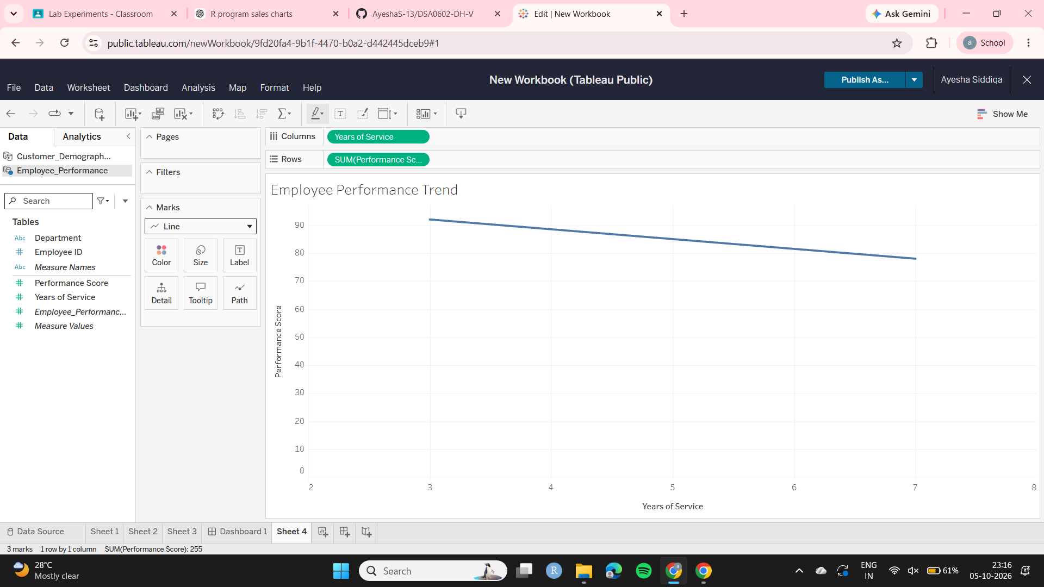
Observation
The performance scores are 85, 92 and 78 for employees having 5, 3 and 7 years of service respectively. The data does not show a consistent relationship between years of service and performance.

Question 2: Generate a Bar Chart Showing Employees Across Departments
Aim
To visualize the distribution of employees across different departments.
Algorithm
- Drag Department to Columns.
- Drag Employee ID to Rows.
- Change Employee ID to COUNT.
- Select Bar Chart.
- Enable data labels.
Tableau Steps
- Columns: Department
- Rows: COUNT(Employee ID)
- Marks: Bar
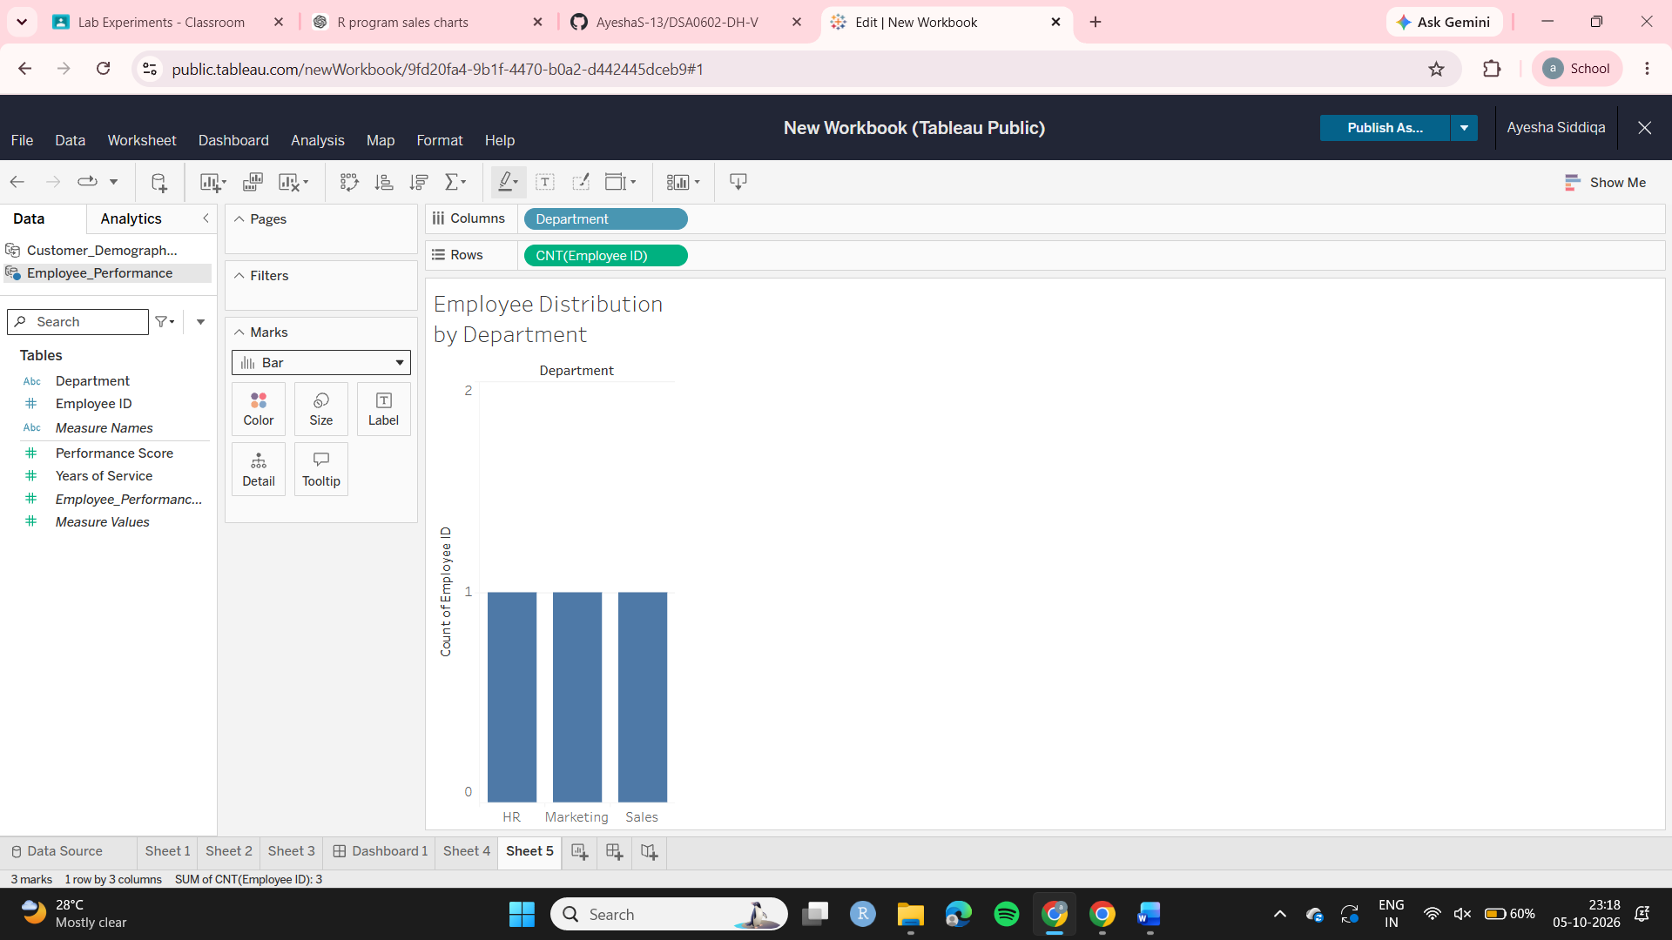
Observation
Each department has one employee.
- Sales = 1
- HR = 1
- Marketing = 1
Therefore, all three departments have equal representation.

Question 3: Build a Table to Display Performance Data
Aim
To display employee performance information in a clear tabular format.
Algorithm
- Select Employee ID.
- Add Department.
- Add Years of Service.
- Add Performance Score.
- Display all information as a table.
Table
Employee ID | Department | Years of Service | Performance Score
1 | Sales | 5 | 85
2 | HR | 3 | 92
3 | Marketing | 7 | 78
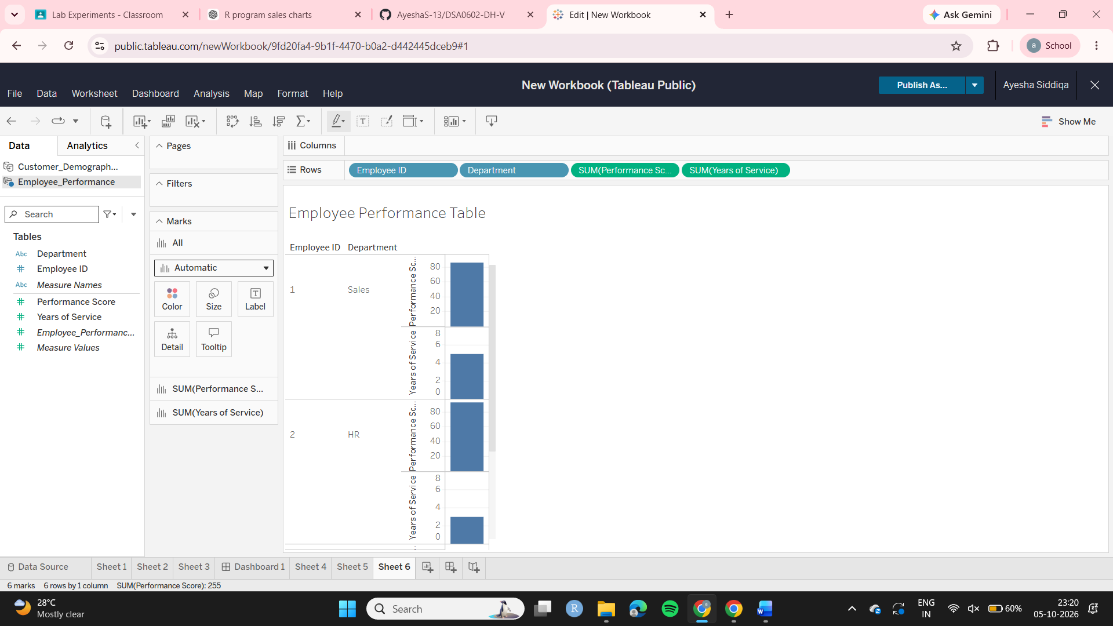
Observation
The HR employee has the highest performance score of 92, while the Marketing employee has the lowest score of 78.

Question 4: Develop a Tableau Dashboard
Aim
To combine the line chart, department bar chart and employee performance table into one interactive dashboard.
Algorithm
- Create the performance line chart.
- Create the department bar chart.
- Create the performance table.
- Select New Dashboard.
- Drag all worksheets into the dashboard.
- Add filters or actions.
- Format the dashboard.
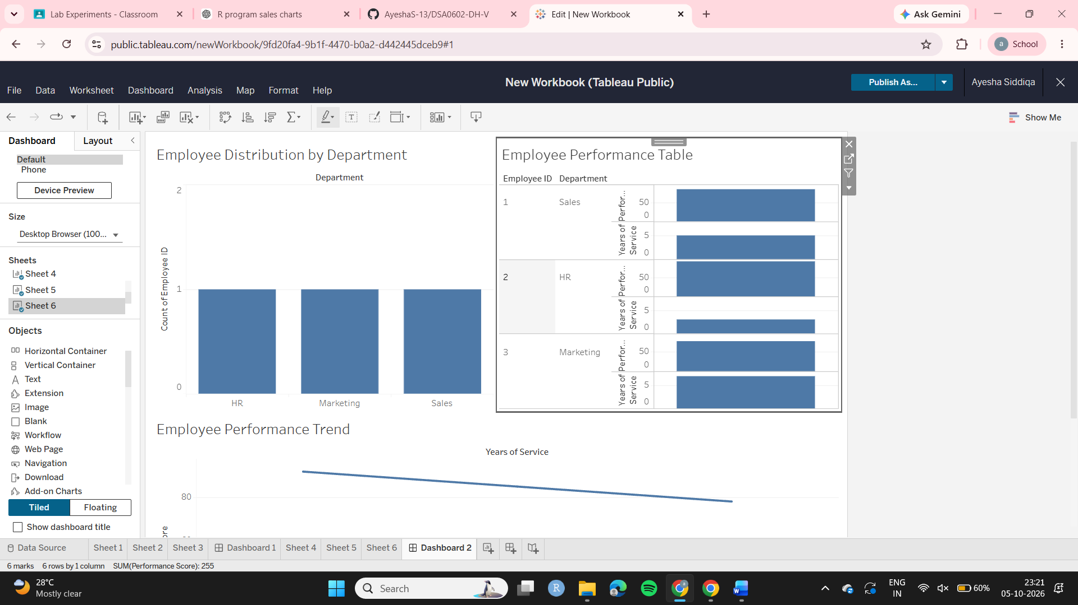
Observation
The dashboard provides a combined view of employee performance, department distribution and years of service, making comparison easier.

